A DAY IN THE LIFE
I Set an AI a Goal. It Wrote Me a Book.
What happened when a psychotherapist with thirty years of clinical experience sat on his sofa with an iPhone 15 and told Claude to write, publish and promote a book on AI behaviour. In one day.

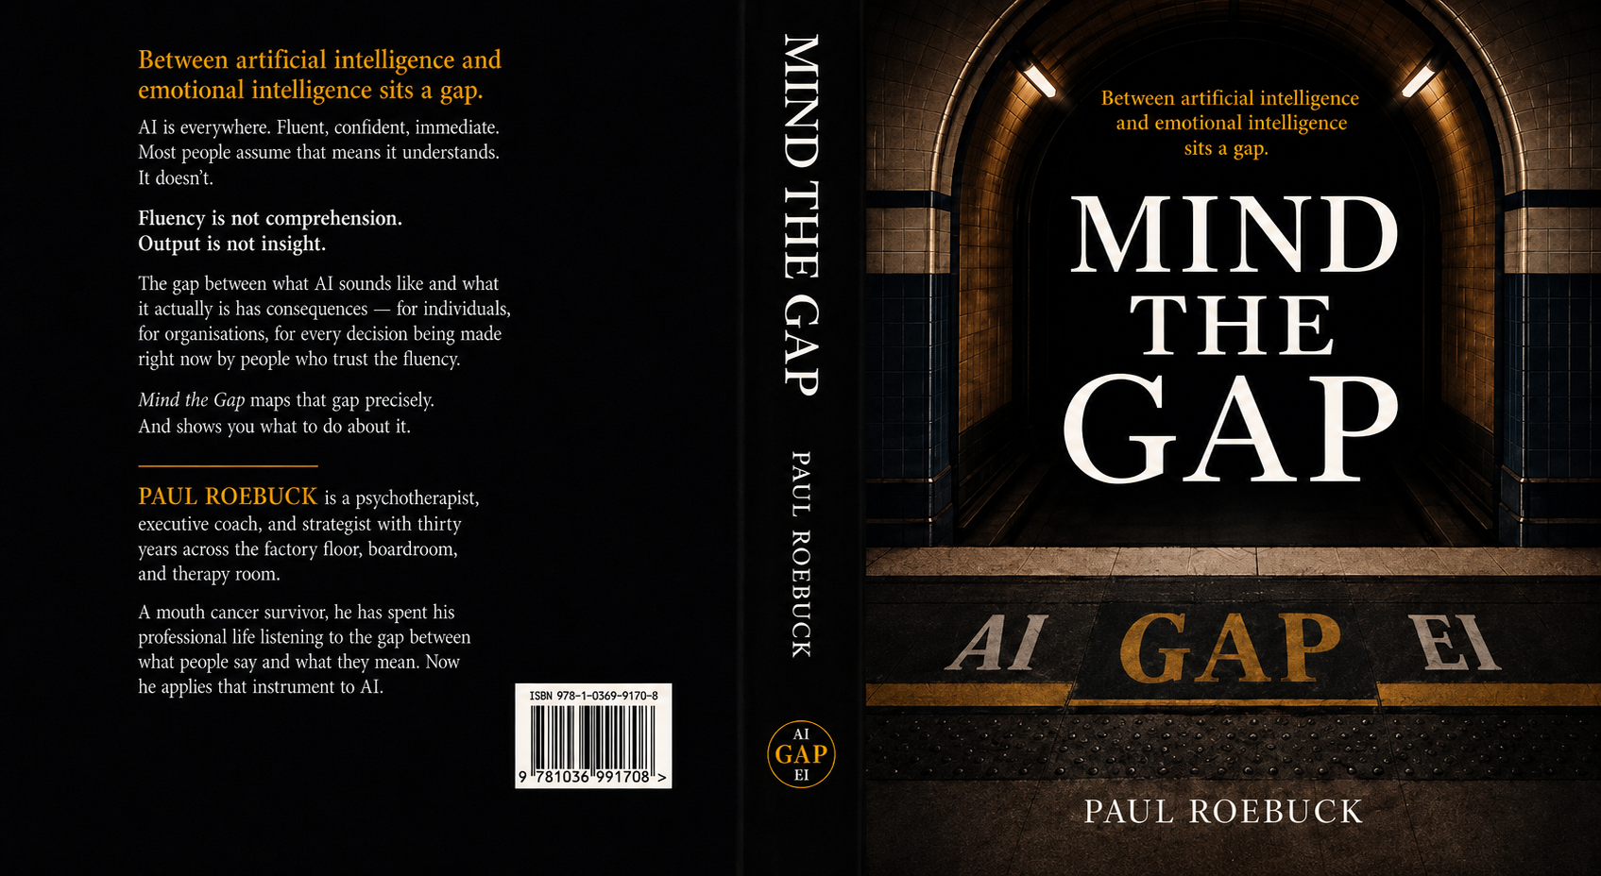
Mind the Gap — Paul Roebuck — ISBN 978-1-0369-9170-8

The Slash Goal
I heard the term slash goal on the Daily AI Podcast. Not a task. A goal. Something with a destination, not just a direction.
I want to be honest about my relationship with that podcast. I used to think it was for techies. Granola, slash goals, MCP connector protocols, agentic frameworks. The first episode I properly remember was the one about MCP being conceived. It made sense as a connector protocol but I was largely clueless about the implementation.
I kept listening anyway. Because underneath the technobabble — and I say that with affection — there was strategic thinking I could use. Anthropic and X. OpenAI moving into Worker as a Service. The commercial consequences of AI deployment at scale. The human stories inside the technical announcements.
I am a psychotherapist and a polymath. I came from a factory floor, went to a boardroom, and ended up in a therapy room. I understand systems. I understand behaviour. I understand what happens when a new technology meets a human being who hasn’t been told what it actually is.
So I kept listening. And last week the podcast said: try a slash goal this weekend.
So I did. On a Monday morning in May 2026, sitting on my sofa, I set Claude a goal.
Write, publish and promote me a book on AI behaviour.
Not write me a chapter. Not draft me an outline. Write, publish and promote a book on AI behaviour. Set the outcome. Define the boundaries. Let the system work.
By the end of the same day, I had a first draft of twelve chapters, a front matter with full dedications, a cover design, an official ISBN from Nielsen UK, a barcode from bookow.com, a bibliography, an illustrated index, a proposal, an academic addendum, a critical reflection, a final assessment, an editorial log, an artefact library of twenty-four documents, and this blog post.
Approximately 27,000 words. One conversation. One day. One sofa. One iPhone 15 Pro Max.
This is not a story about what AI can do. It is a story about what happens when a human with thirty years of accumulated knowledge sets a goal and gives a second intelligence the capability to help pursue it.

The Instrument
I am a psychotherapist. I have been working the gap between what people say and what they mean for thirty years. Factory floor, boardroom, therapy room. I have sat with grief, shame, fear, ambition, cancer, and the peculiar courage it takes to tell the truth about yourself in a room with someone who is paid to listen.
When conversational AI arrived, I recognised the territory immediately.
Fluency mistaken for understanding. Confidence mistaken for accuracy. The surface of a conversation concealing what was actually operating underneath. The gap between what the system outputs and what produces the output.
I had been working that gap for thirty years. Just not with machines.
The book is called Mind the Gap. AI on one side. EI on the other. The empty platform between them — the thinking zone — is where human cognition, reflection, and emotional processing live. The argument is simple: AI sounds like it understands. It doesn’t. That gap has consequences. The only way to navigate it is to understand it.

How It Actually Worked
I directed. Claude wrote. That is the accurate description.
The ideas are mine. The clinical framework is mine. The life is mine. The authority — earned across thirty years, sharpened by cancer, forged in rooms where the gap between what people say and what they mean is the entire work — is mine.
What Claude brought was capability. Speed. Synthesis. The capacity to hold context across a long conversation and produce structured prose from unstructured direction.
I sat on my sofa. I typed on my phone. I shared files as they came to mind. I corrected register when the prose was too smooth. I caught drift when the conversation wandered. I held the thread when the context window began to compress. I said this is wrong, try again. I said this is right, keep going.
And I brought the things that cannot be generated. The cancer. The father who died when I was five. The therapy room. The moment a client said we don’t talk about that and I understood exactly what that meant because I had once said it myself.
The Additional Intelligence has no authority here. I have the authority. It has the capability. Together we produced something neither could have produced alone. That is what Additional Intelligence means.

The Simplicity and the Complexity
The simplicity: I opened Claude. I set a goal. I described what I knew. I shared what I had. I corrected what was wrong. I kept what was right. Anyone with a Claude Max subscription, a body of knowledge, and the discipline to direct rather than delegate can do what I did.
The complexity: I did not arrive empty-handed. I arrived with thirty years of clinical practice, three originated clinical frameworks, fifteen years of published content, a visual deck built over months, a partially written companion book, a cancer survivorship, and the specific kind of intelligence that comes from paying attention to people for a living.
The AI did not produce the authority. I brought the authority. The AI produced the structure around it.
The system is a mirror. It reflects what you give it. Give it thirty years of lived and learned expertise and it reflects something worth reading. Give it nothing and it gives you nothing back, however fluently it says it.

Top 5 Tips
These are not prompting tips. They are behavioural disciplines.

1. Set a goal, not a task.
Tell the system what success looks like, not what to do next. Goals produce books. Tasks produce paragraphs.
2. Bring your authority. All of it.
The system cannot generate expertise. Before you open Claude, ask: what do I know that nobody else knows in quite the same way? That is the raw material. The system is the workshop.
3. Direct. Don’t delegate.
Stay present. Read every paragraph. Mark what sounds wrong. Correct it immediately. The system does not know when it has drifted. You do.
4. Ask it to replay.
Before significant work, ask the system to play back its understanding of the task. The gap between what you meant and what it understood is information. Find it before the work starts, not after.
5. Hold the thread yourself.
In a long conversation, the system compresses. You are not. Keep a note of what has been agreed, what has been flagged, what still needs doing. The editorial log I built during the day was the human thread that held the manuscript together.

The Art of the Possible
Four weeks after signing up for Claude Max. One day to write the book. Thirty years to have something worth writing.
If you are sitting on your sofa with a body of knowledge and a goal you have been putting off — I am telling you something important.
You have everything you need.
Set the goal. Not the task. The goal.
See what happens.

Paul Roebuck
Psychotherapist, Executive Coach, and Author of Mind the Gap
www.paulroebuck.co.uk
Warwickshire, May 2026
Research: Claude AI (Anthropic) — claude-sonnet-4-6, May 2026
Written and posted by Paul Roebuck — paulroebuck.co.uk

A NOTE TO THE DAILY AI PODCAST
From Paul Roebuck — Psychotherapist, Author, and Listener

I want to tell you something about your podcast.
I used to think it was for techies. Granola. Slash goals. MCP connector protocols. I remember the episode where MCP was being conceived. I understood the concept — a connector protocol, a standard for AI tools to talk to each other — but the implementation was way beyond me. I filed it under interesting and moved on.
I kept listening because underneath the technical detail, there was strategic thinking I could actually use. Anthropic and X. OpenAI moving into Worker as a Service. The commercial consequences of AI deployment at scale. The moment when the news stopped being about what the technology could do and started being about what it was doing to people, organisations, and industries.
That is my territory. I am a psychotherapist. I study behaviour for a living. And for the past three years I have been watching AI do to human behaviour exactly what I spent thirty years learning to diagnose and address in therapy rooms and boardrooms.
Then last week you said: try a slash goal.
So I did.
On a Monday morning in May 2026, sitting on my sofa, I told Claude to write, publish and promote me a book on AI behaviour. Not a chapter. Not an outline. A book. By the end of the same day I had a first draft of twelve chapters, an official ISBN from Nielsen UK, a full cover design, and twenty-four supporting documents.
The book is called Mind the Gap. It is about the gap between what AI sounds like and what it actually is. It is written by a psychotherapist who recognised that gap immediately, because he had been working it — in human conversations — for thirty years.
I am sending you a copy.
And I hope one day to be your podcast guest. Not to talk about the technology. To talk about what happens to human beings when they encounter it without understanding what it is. That is the gap your listeners — techies and non-techies alike — are living in every day.
I can talk about that gap in a way that very few people in this space can. Because I have been there. In the therapy room, in the boardroom, in the cancer ward, and now on my sofa with my iPhone 15.
Thank you for the slash goal. Here is what it produced.

Paul Roebuck
PGCEE, MNCS (Accred), FETC (Ad.Dip)
paul@paulroebuck.co.uk
www.paulroebuck.co.uk
Warwickshire, May 2026

